**Here are the chart types in Power BI:**

**1. Area Charts :**

The area chart depends on line charts to display quantitative graphical data. The area between the axis and lines is commonly filled with colors, textures, and patterns.

**2. Line Charts :**

Line charts are mostly used charts to represent the data and are characterized by a series of data points connected by a straight line.

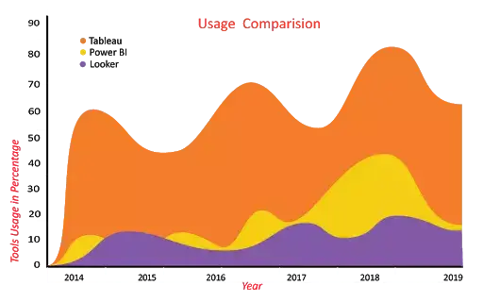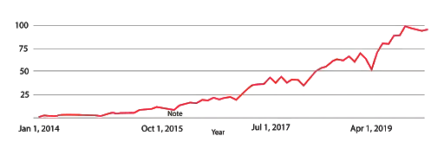

**3. Bar Charts :**

Bar charts are mostly used graphs because they are simple to create and easy to understand. Bar charts are also called horizontal charts that represent the absolute data.

**4. Column Charts :**

Column charts are similar to bar charts, and the only difference between these two is, column chart divides the same category data into the clusters and compares within the clusters. Also, it compares the data from other clusters.

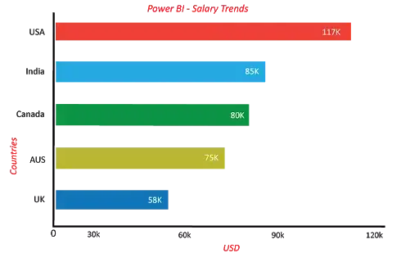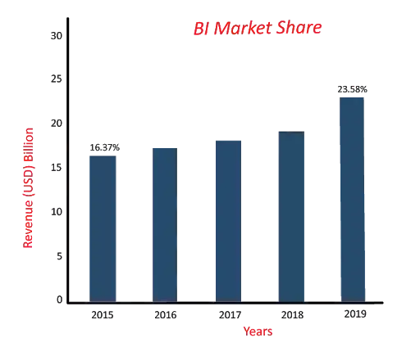

**5. Pie Charts :**

A pie chart is a circular statistical chart, and it shows the whole data in parts. Each portion of a pie chart represents the percentages, and the sum of all parts should be equal to 100%.

**6. Gauge Charts :**

A gauge chart is also known as a speedometer or dial chart. It uses the needle to read the data, and it shows the information on a dial.

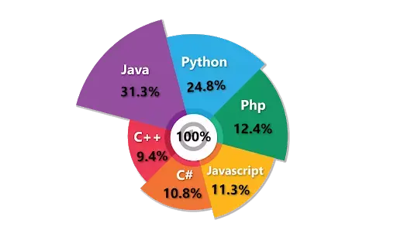 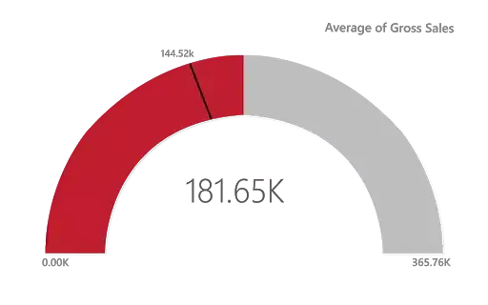

**7. Funnel Charts :**

The funnel chart is a type of chart which is used to visualize the data that flows from one phase to another phase. In the funnel chart, the whole data is considered as 100%, and in each phase, it is represented as numerical propositions of the data.

**8. Maps :**

A point map is used to represent the geographical distribution of data by plotting the same size points on the geographical background.

 